June 19, 2018

2018-19 ANNUAL ASBESTOS NOTIFICATION LETTER

Dear Parents/Guardians and Students;

Congress passed the Asbestos Hazard Emergency Response Ace (AHERA) in 1986. This act concerns asbestos in schools. As a result of this act, our facilities were inspected for asbestos containing building materials and their conditions assessed. Every 3 years our facilities are re-inspected and re-assessed. We also continue to monitor the conditions of these materials through our ongoing six-month surveillance program. It is our district’s intent to comply with federal, state and local regulations governing asbestos to ensure a safe environment for our students, staff and visitors.

In the past year, our district conducted the following asbestos related inspections/work:
- Abatement of pipe fittings at Wilson Talent Center
- Abatement of pipe fittings at Thorburn Education Center
A copy of our district’s Asbestos Management Plan is available at our facilities’ administrative office during regular school hours. If you would like to set up a time to review this plan and/or if you have any questions regarding the plan, please contact the Facilities Department at 517.244.1235 or nbelman@inghamisd.org. Please give the following information: your name, email address/mailing address/phone number, student’s name and the school your child attends. Feel free to leave a detailed message if your call goes to voicemail.

Sincerely,
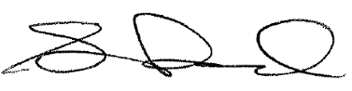

Steve Rusnock
Director of Facilities and Safety

